## **MUSIC STORE ANALYSIS**

## **USING SQL**

## **BY Shama Mohammad**

**INSIGHTS:**

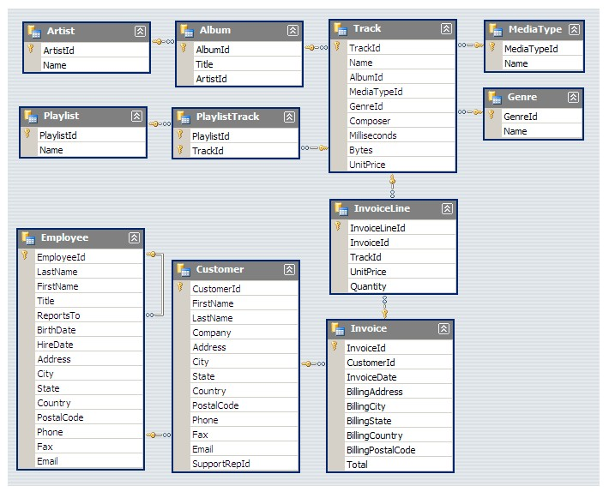This SQL project explores the world of music using a comprehensive music store dataset. By leveraging SQL queries, this project aims to provide insights into various aspects of the music industry, including sales analysis, customer behaviour, and genre preferences.

* Who is the senior most employee based on job title?

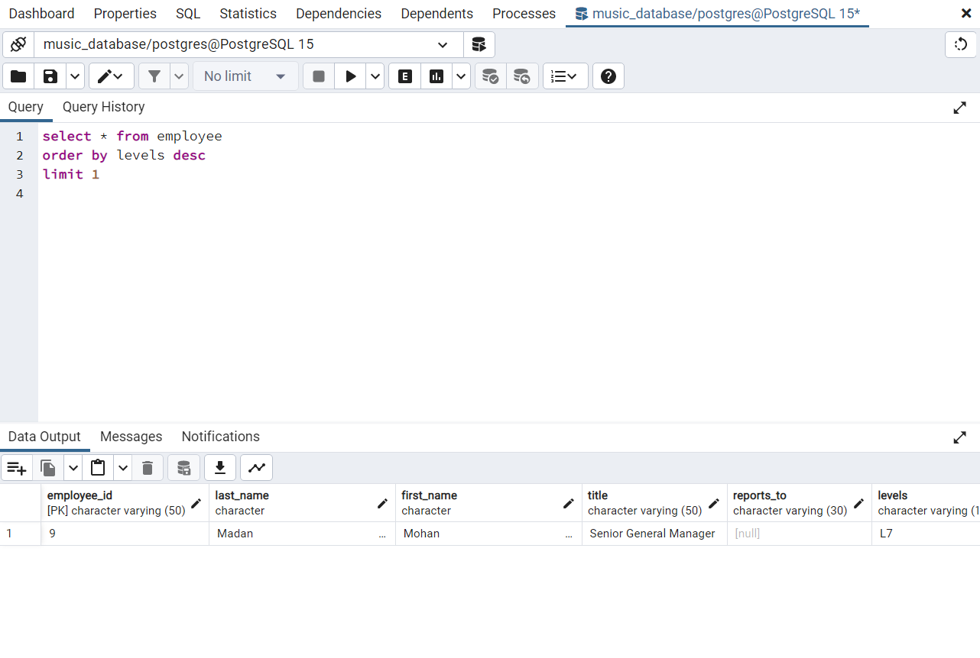

* Which countries have the most Invoices?

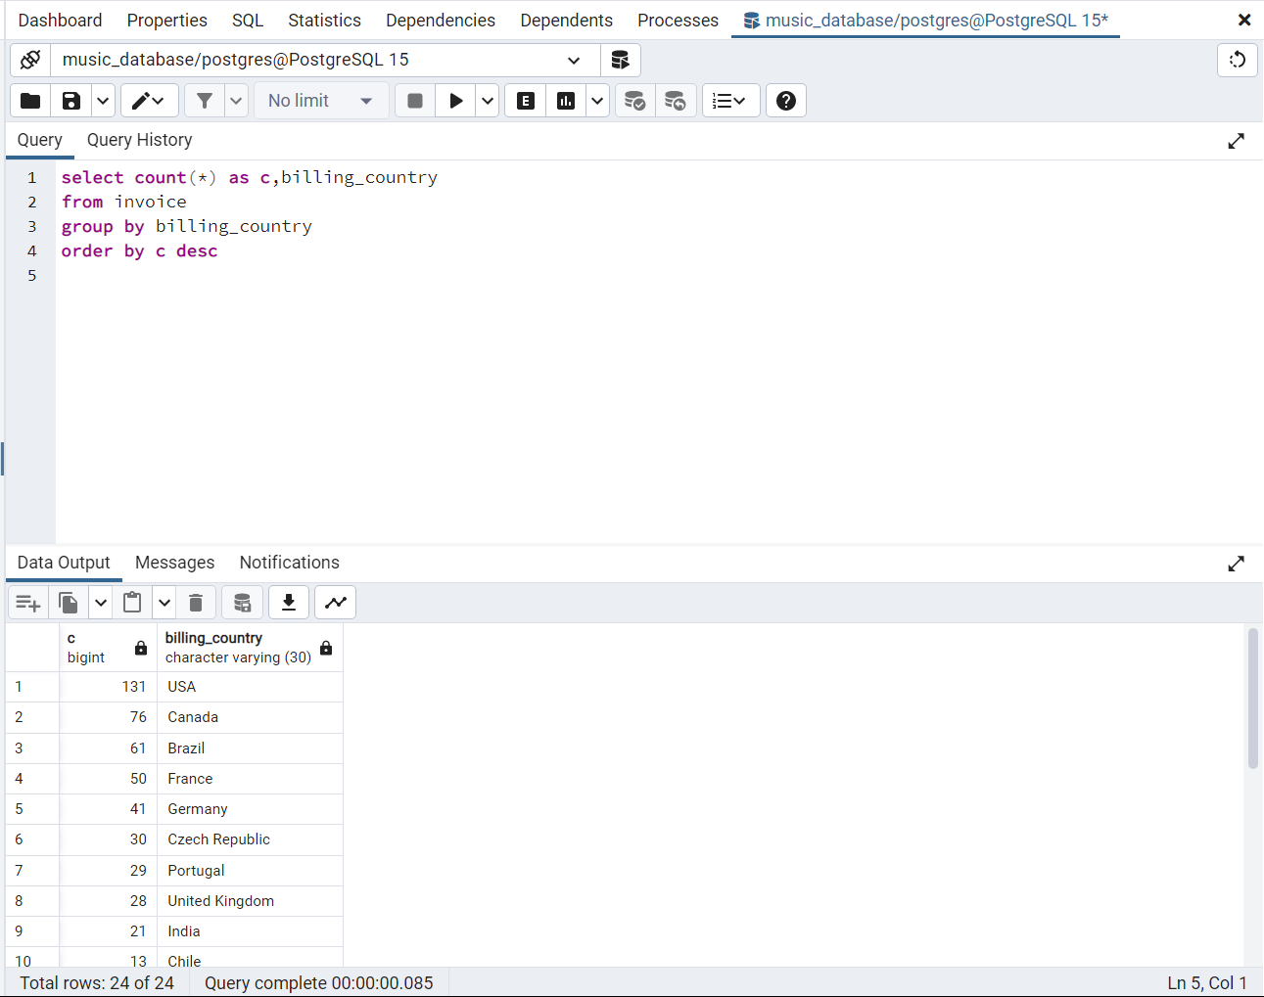

* What are top 3 values of total invoice?

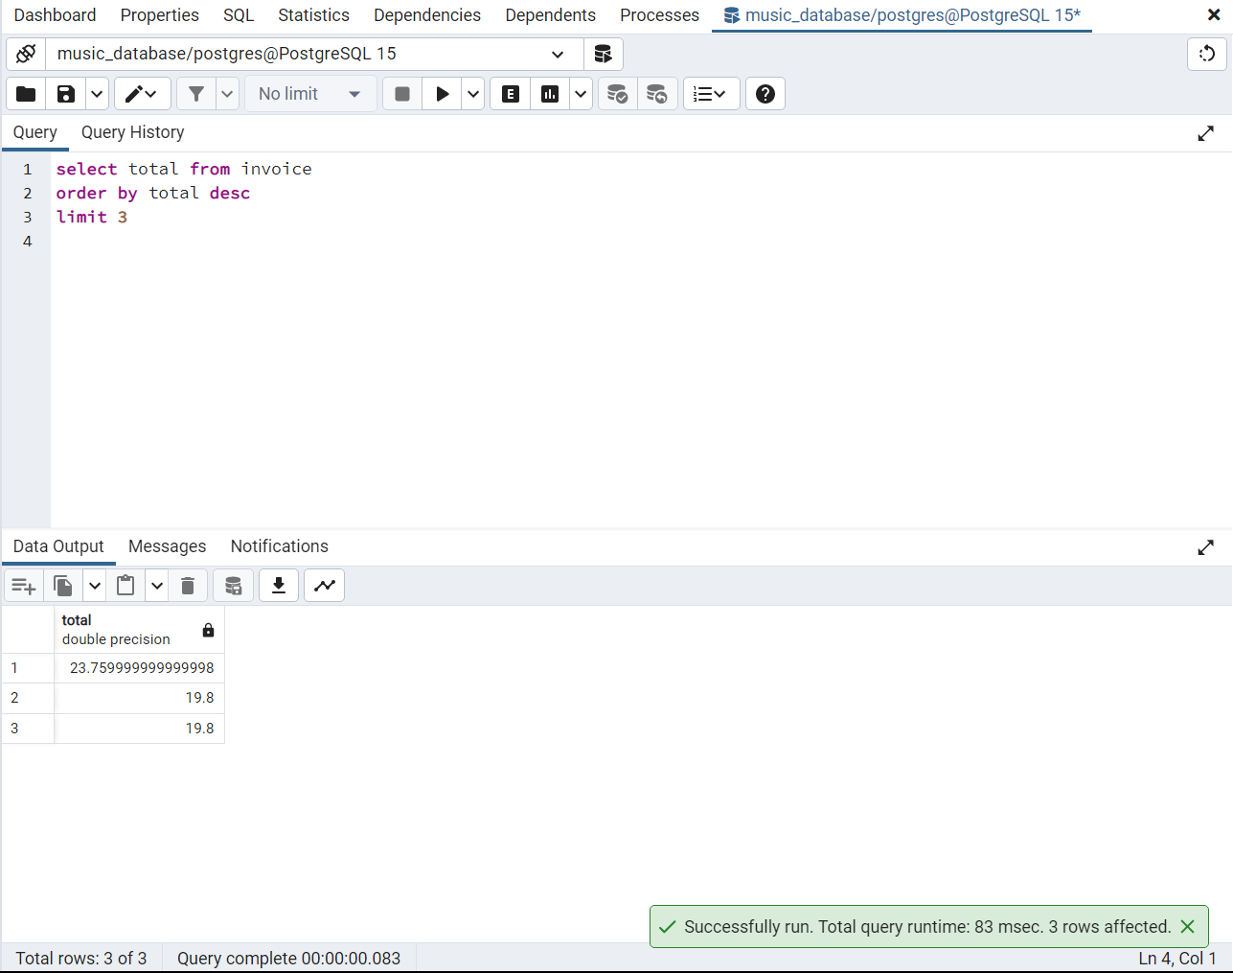

* Which city has the best customers? We would like to throw a promotional Music Festival in the city we made the most money. Write a query that returns one city that has the highest sum of invoice totals. Return both the city name & sum of all invoice totals?

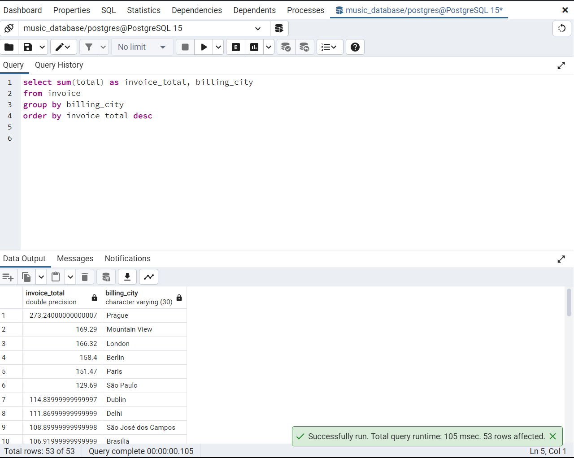

* Who is the best customer? The customer who has spent the most money will be declared the best customer. Write a query that returns the person who has spent the most money

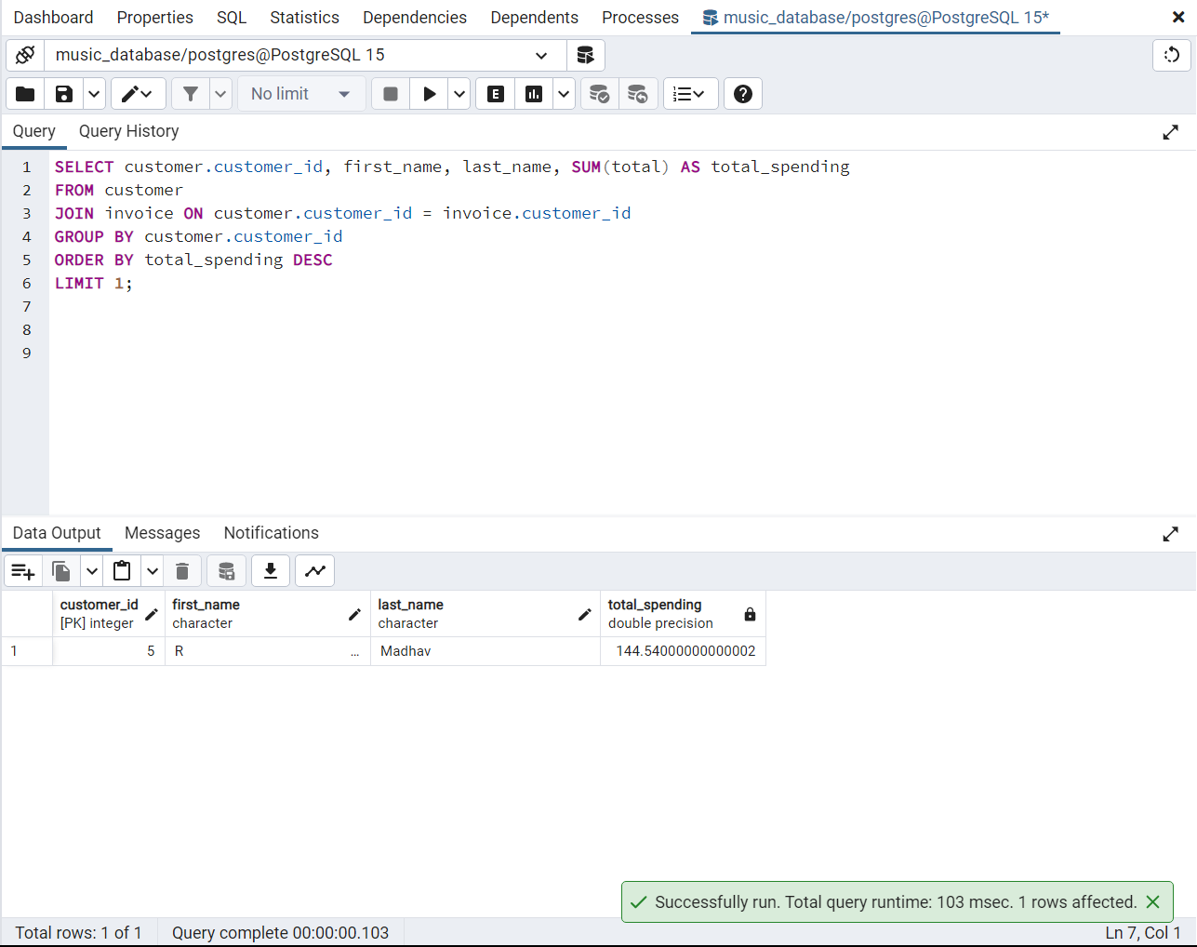

* Write query to return the email, first name, last name, & Genre of all Rock Music listeners. Return your list ordered alphabetically by email starting with A

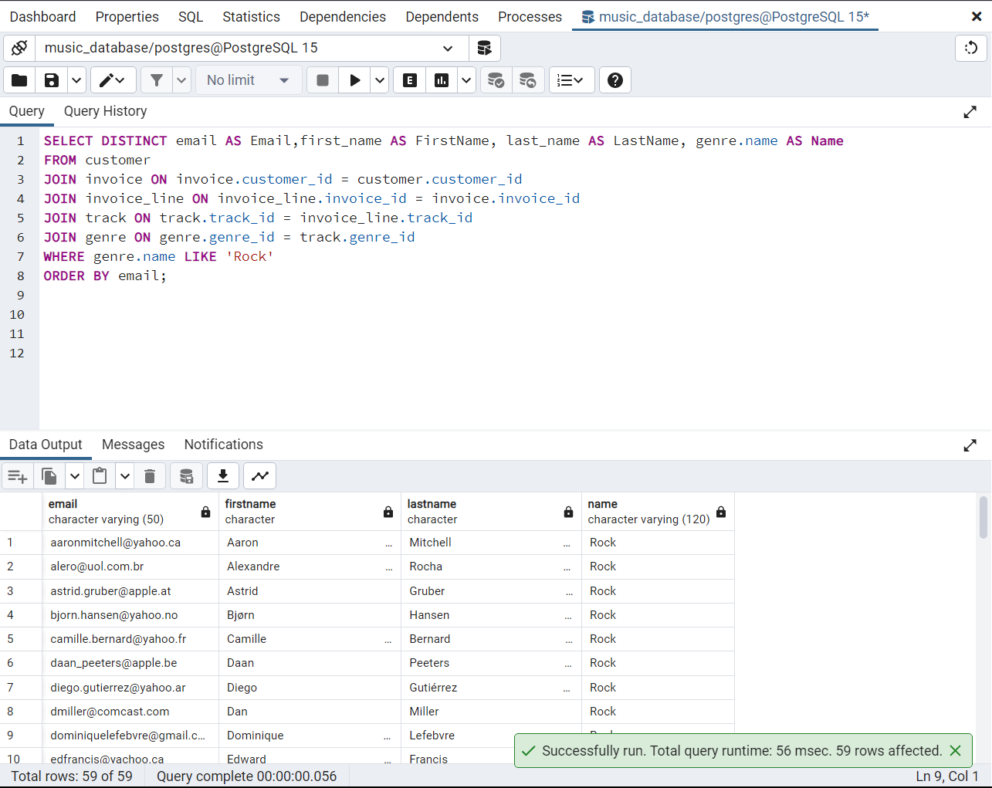

* Let's invite the artists who have written the most rock music in our dataset. Write a query that returns the Artist name and total track count of the top 10 rock bands

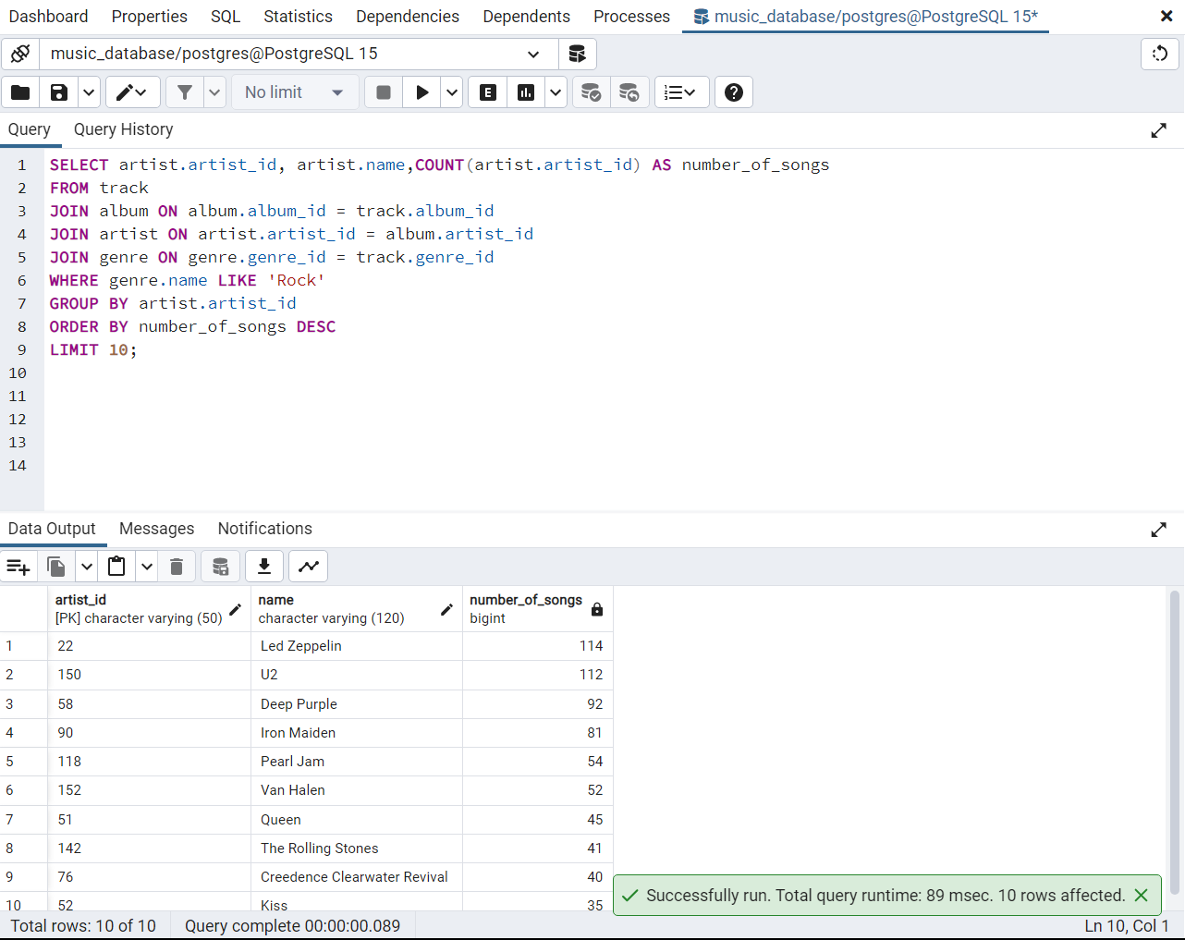

* return all the track names that have a song length longer than the average song length. Return the Name and Milliseconds for each track. Order by the song length with the longest songs listed first

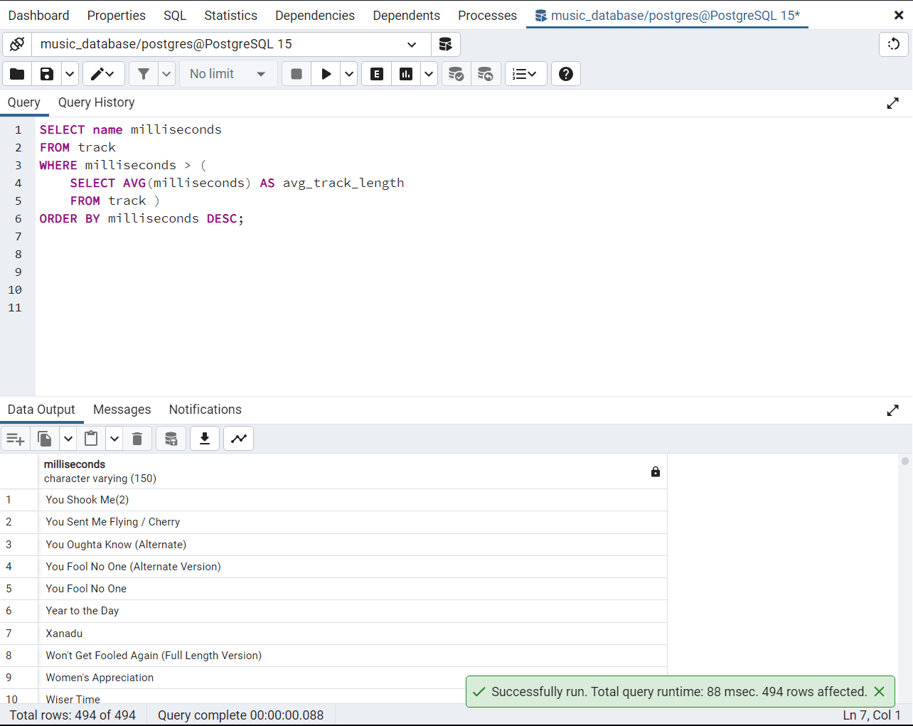

* Find how much amount spent by each customer on artists? Write a query to return customer name, artist name and total spent.

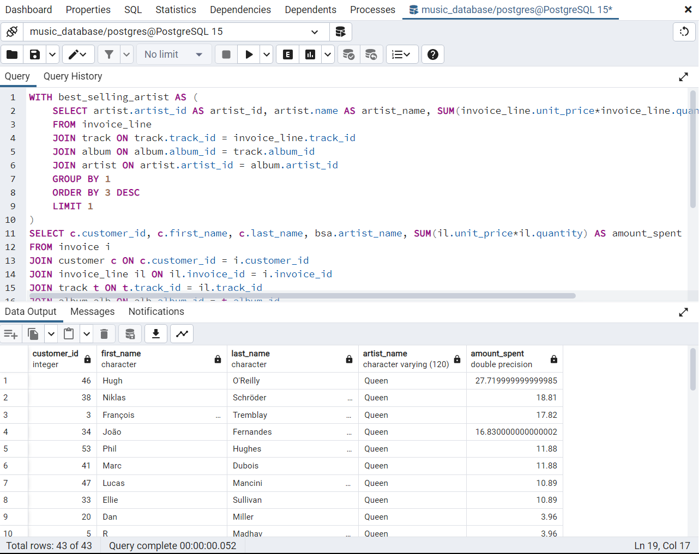

* We want to find out the most popular music Genre for each country. We determine the most popular genre as the genre with the highest amount of purchases. Write a query that returns each country along with the top Genre. For countries where the maximum number of purchases is shared return all Genres

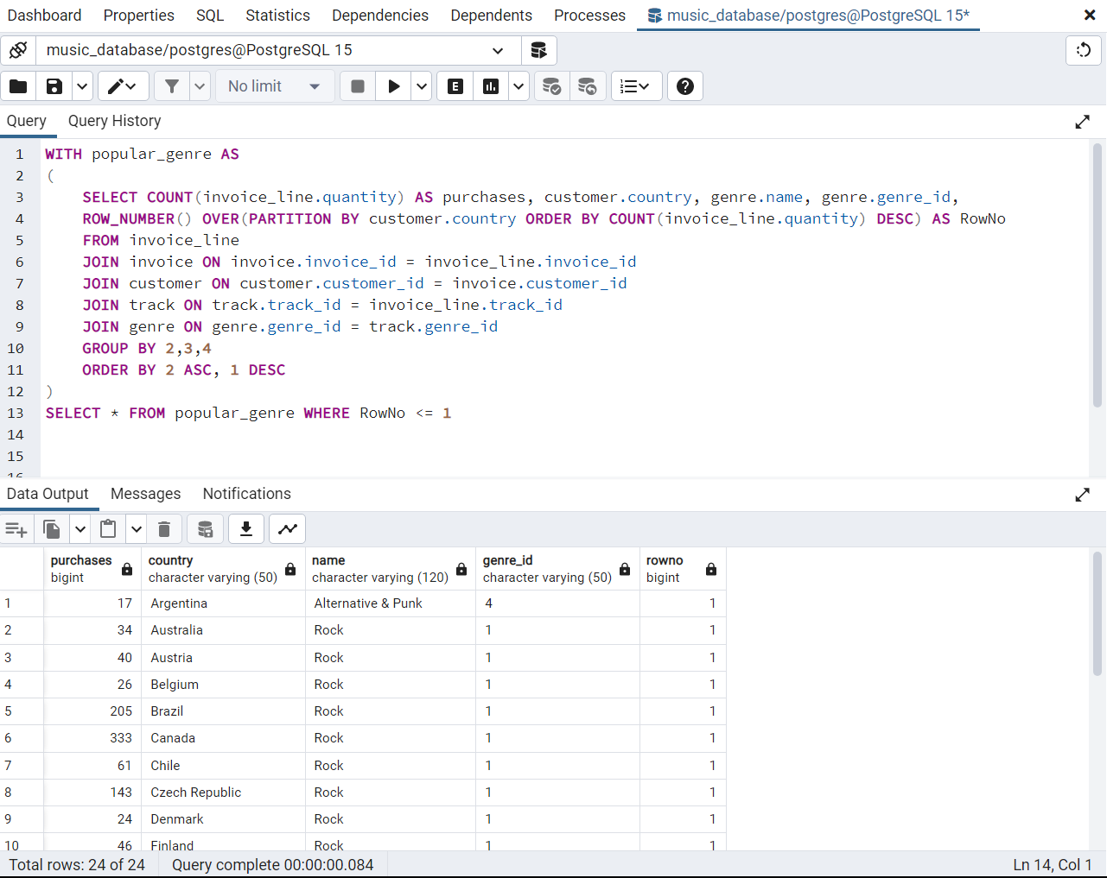

* Write a query that determines the customer that has spent the most on music for each country. Write a query that returns the country along with the top customer and how much they spent. For countries where the top amount spent is shared, provide all customers who spent this amount

“

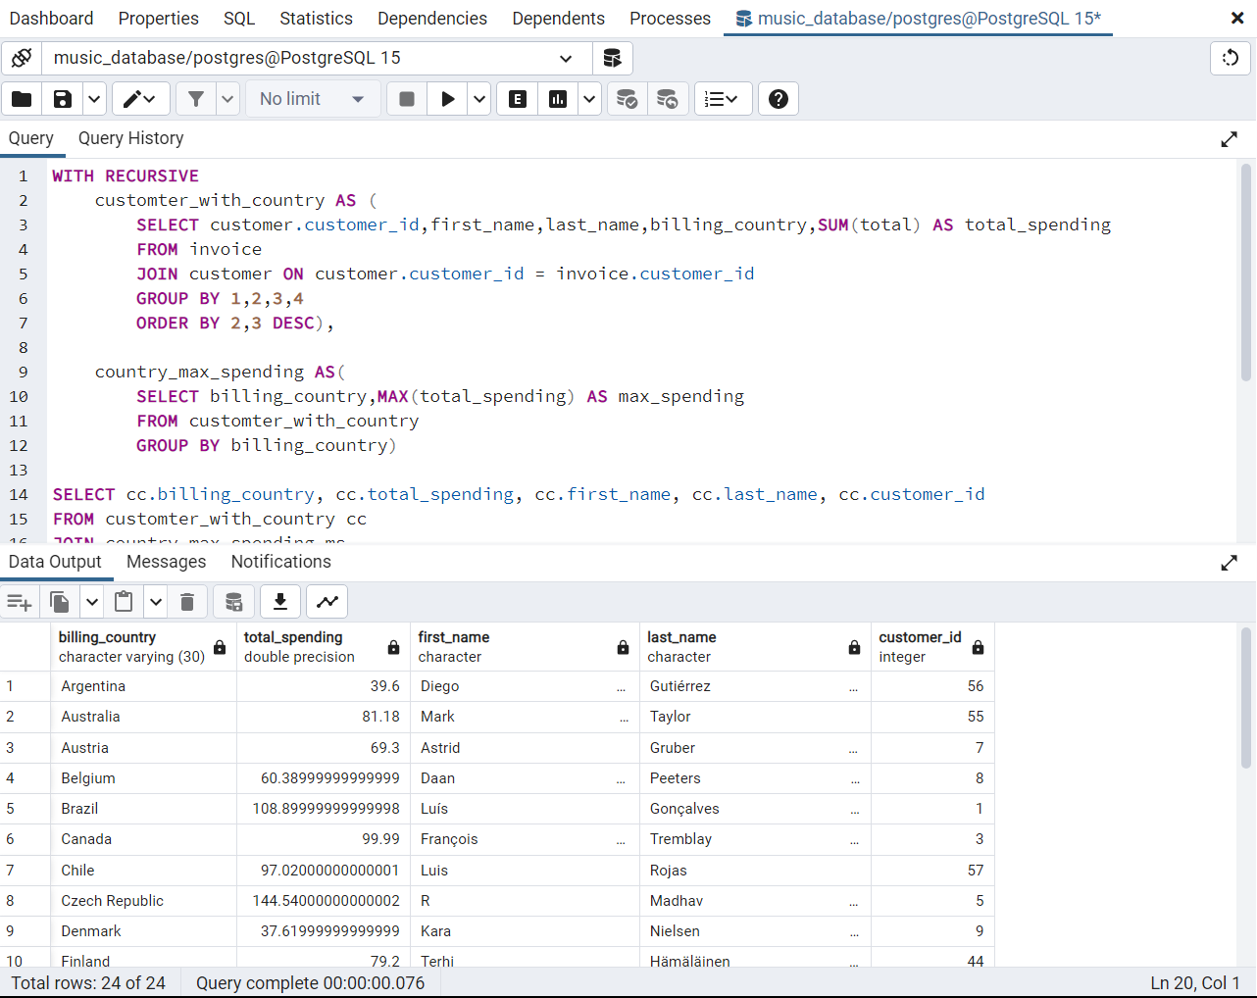

**Conclusion:**

•The city of Prague stands out as a significant contributor to the company's revenue, with the highest total invoice amount and the top two customers in terms of expenditure originating from this location.

•The analysis indicates that rock music is the most popular genre across all countries, with the exception of Argentina, where it appears to have less demand. This insight provides valuable information for music selection and promotion, suggesting a focus on rock music in marketing campaigns and product offerings.

•U2 emerges as the artist who has written the most rock music, further solidifying their prominence in the genre. This finding showcases the influence and popularity of U2's music within the company's customer base.

•The majority of customers are based in Europe, comprising approximately 70% of the customer base.

•There is a notable discrepancy in the number of employees at the senior and junior levels, with fewer individuals occupying senior positions.